Name: _________________ PS ID# ___ COSC 3380

HW 1
(100 points)
(Due date found in the COSC 3380 Detailed Syllabus!)

Electronic: a Word document HW 1.doc and a PDF document HW 1.pdf to be attached to the BB Assignment.
BASED on LECTURE 2 DATA MODELING - WHAT - ERD MODEL

1. (15 points) Data Requirements Analysis for ERD
(You need to do the Textual Analysis on the Requirements below using Word, then select all annotations, copy and paste on a new page)
(HW1.doc)

Construct an ERD Model for a car insurance company whose customers own one or more cars each. Customer’s customer_id, name, and address need to be stored in the database. Each car has associated with it zero to any number of recorded accidents. Both car’s licence_no and model data need to be stored in the database. Accident’s report_id, date, and place need to be stored in the database. Each insurance policy (has a policy_id) covers one or more cars, and has one or more premium payments (amount) associated with it. Each payment (has a payment_no) and is for a particular period of time, and has an associated due date, and the date when the payment was received.

ANSWER:

Templates:

E1: Customer
R2: Place
(1 E1: Customer “Place” M E6: Orders)
E1: Customer – A1: C_ID
2. (10 points) Data Requirements Analysis for ERD
(You need to do the Textual Analysis on the Requirements below using Word, then select all annotations, copy and paste on a new page)
(HW1.doc)

Consider a database used to record the marks that students get in different exams of different course offerings (sections). Student’s student_id, name, dept_name, and tot_cred need to be stored in the database. Section’s sec_id, semester, and year need to be stored in the database. Course’s course_id, title, and credits need to be stored in the database. Exam’s exam_id, name, place, and time need to be stored in the database.

a.
Construct an E- R diagram that models exams as entities, and uses a ternary relationship between student, section, and exam, for the database.

ANSWER:

b.
Construct an alternative E- R diagram that uses only a binary relationship between student and section. Make sure that only one relationship exists between a particular student and section pair, yet you can represent the marks that a student gets in different exams.

ANSWER:

BASED on LECTURE 3 DATA MODELING HOW - RELATIONAL MODELS

3. (10 points)
(By hand, scan the pages with your phone as HW1.pdf)
Please make sure you identify your answer, like 3 a, 3 b, 3 c, 3 d

Since Relations are sets and, thus, cannot have identical elements, the set of all attributes in a Relation must be a superkey. If this is not a minimal superkey, some strict subset of it must also be a superkey. Since the number of the attributes in every Relation is finite, we will eventually get a minimal superkey, i.e., a key of the Relation.

Define the following concepts:

a. Key

ANSWER:

b. Candidate key

ANSWER:

c. Primary key

ANSWER:

d. Superkey

ANSWER:

4. (10 points)
(By hand, scan the pages with your phone as HW1.pdf)
Please make sure you identify your answer, like 4 a, 4 b

a. Given Relation R with four attributes ABCD and the set of FD s:

ABC → D
D → A

are ABC and BCD candidate keys?

ANSWER:

 | A | B | C | D

b. Given Relation R with four attributes ABCD and the set of FD s:

AB → C
AB → D
C → A
D → B

what is(are) the candidate key(s)?

ANSWER:

 | A | B | C | D

BASED on LECTURE 4 ERD to RELATIONAL

5. (10 points) ERD Model to TEXTBOOK ERD Model to Relational Model, table format (by hand, scan the pages with your phone as HW1.pdf)
Please make sure you identify your answer, like 5 a, 5 b

- Translate this ERD Model to the TEXTBOOK ERD Model

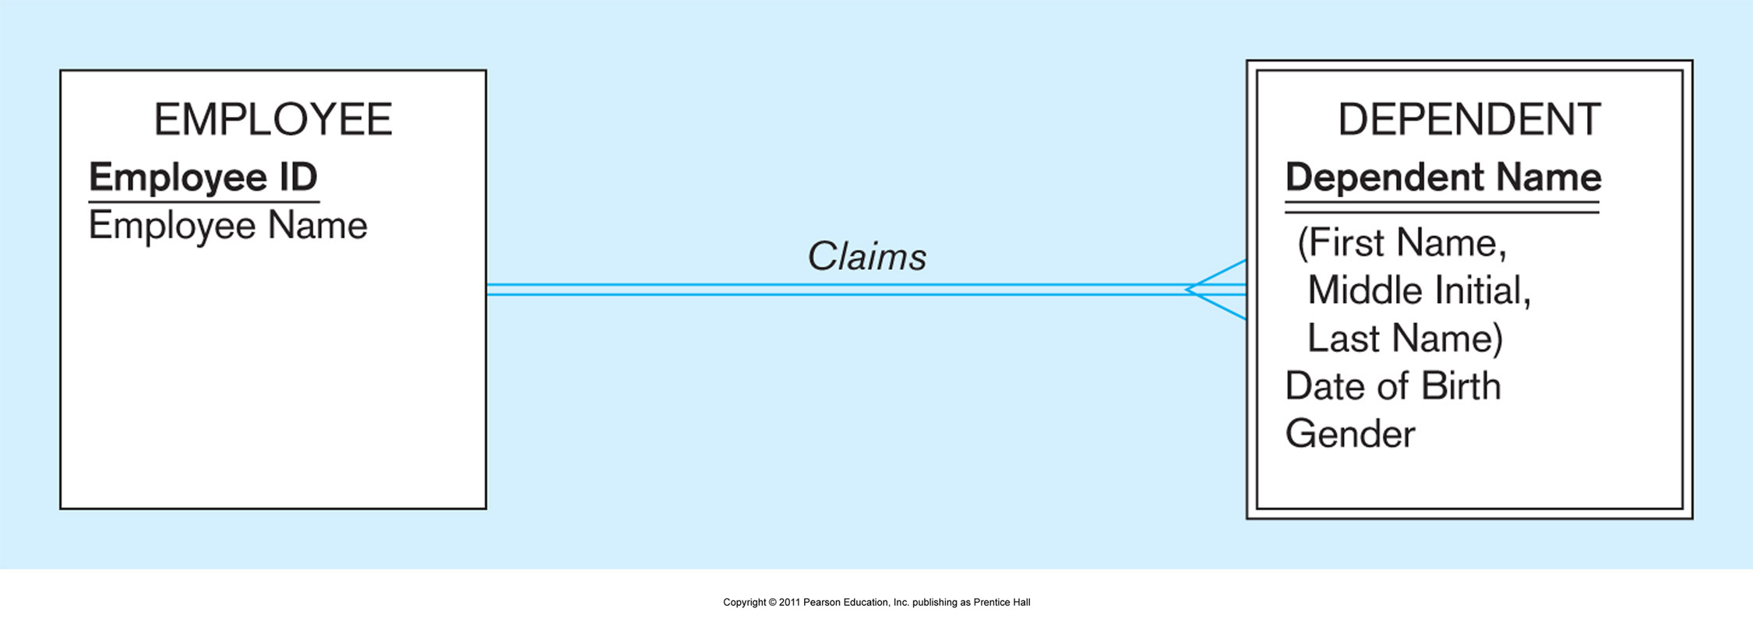
ANSWER:

- Translate the TEXTBOOK ERD Model to Relational Model
(Copy your ERD from a., mark it with labeled ovals, then write the TABLE…. under or side. Please make good use of the “real estate” below).

ANSWER:

6. (10 points) ERD Model to TEXTBOOK ERD Model to Relational Model, table format (by hand, scan the pages with your phone as HW1.pdf)
Please make sure you identify your answer, like 6 a, 6 b

- Translate this ERD Model to the TEXTBOOK ERD Model
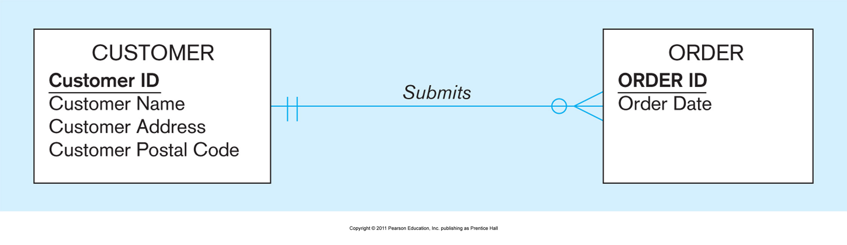
ANSWER:

- Translate the TEXTBOOK ERD Model to Relational Model
(Copy your ERD from a., mark it with labeled ovals, then write the TABLE…. under or side. Please make good use of the “real estate” below).

ANSWER:

7. (15 points) ERD Model to TEXTBOOK ERD Model to Relational Model, table format (by hand, scan the pages with your phone as HW1.pdf)
Please make sure you identify your answer, like 7 a, 7 b

- Translate this ERD Model to the TEXTBOOK ERD Model
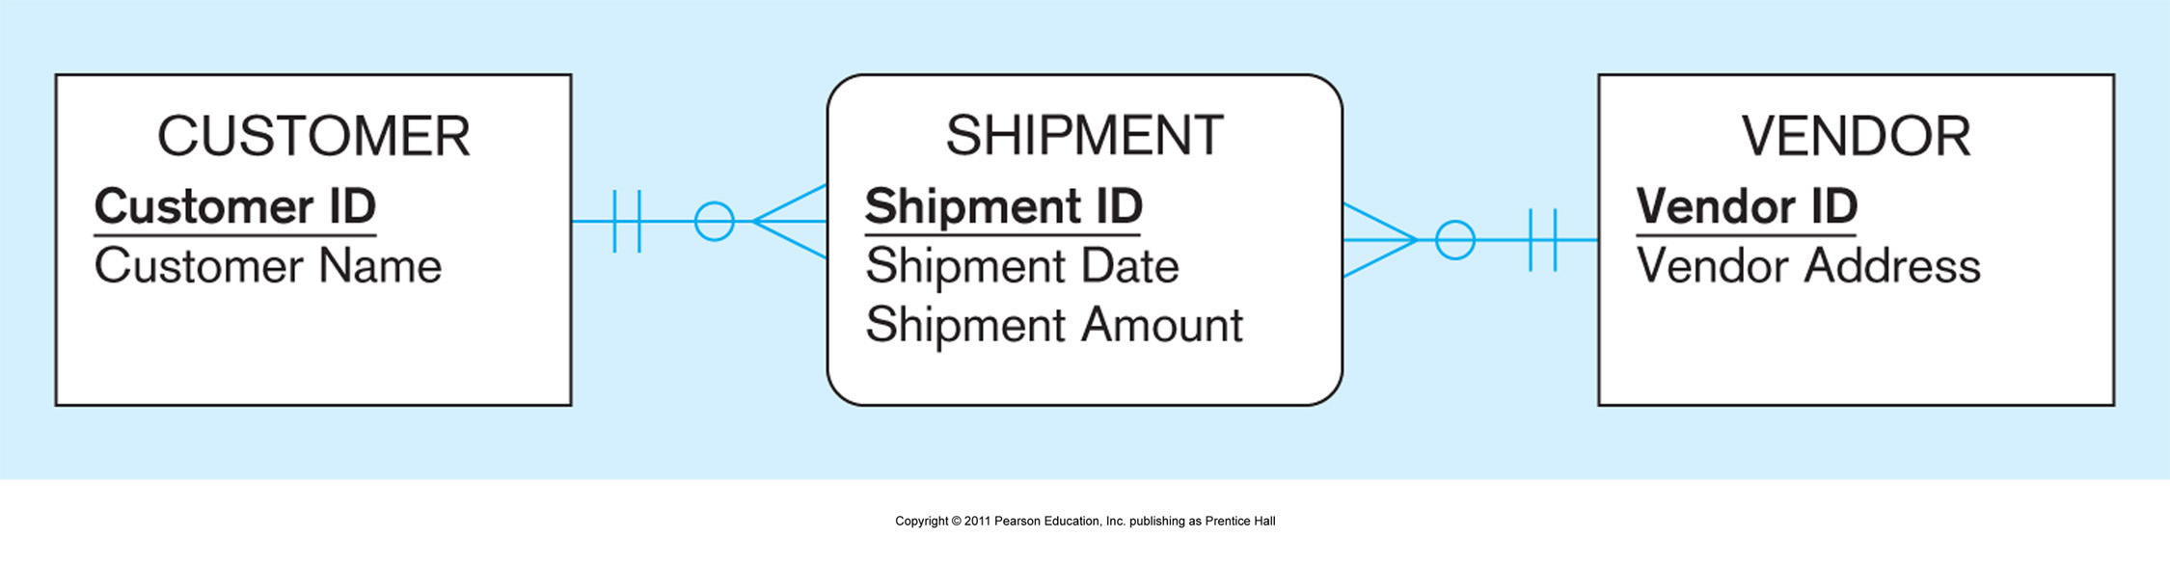
ANSWER:

- Translate the TEXTBOOK ERD Model to Relational Model
(Copy your ERD from a., mark it with labeled ovals, then write the TABLE…. under or side. Please make good use of the “real estate” below).

ANSWER:

BASED on LECTURE 5 NORMALIZATION

8. (10 points)
(By hand, scan the pages with your phone as HW1.pdf)
Please make sure you identify your answer, like 8 a, 8 b, 8 c

Consider a Relation R with five attributes A, B, C, D, and E. The following dependencies are given:

AB → C,
BC → D,
CD → E,
DE → A.

 | A | B | C | D

- List all keys for R. Do not list superkeys that are not a key.

- Is R in 3NF? Briefly explain why.

- Is R in BCNF? If yes, please explain why. Otherwise, decompose R into relations that are in BCNF.

ANSWER:

9. (10 points)
(By hand, scan the pages with your phone as HW1.pdf)
Please make sure you identify your answer, like 9 a, 9 b

R(A, B, C) with FD's

AB -> C,
C -> B

 | A | B | C

- In BCNF? Why or why not?

- In 3NF? Why or why not?

ANSWER:

